WALT: use the language of position.

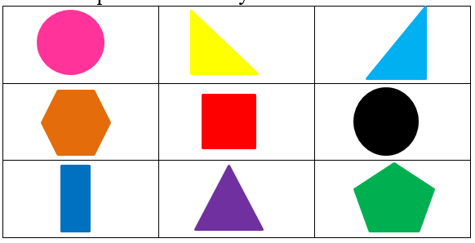
The is _________ the .
The is ________ the .
The is to the _______of the .
The is to the _______of the .
The is ________ the and the

