Macaroni Cheese
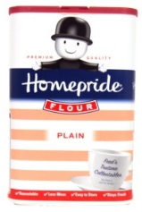 | 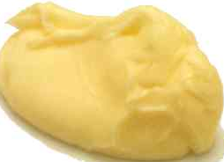 | 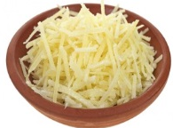 | 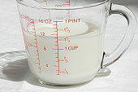 | 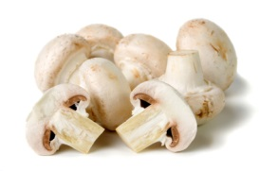 | 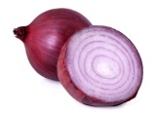 | 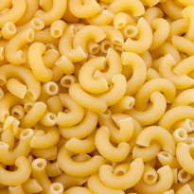
50g  Plain Flour | 50g butter | 250g Grated Cheese | 500ml Milk | 200g  Mushrooms | 2 Chopped onions | 350g spiral pasta
1. Heat oven to 180C

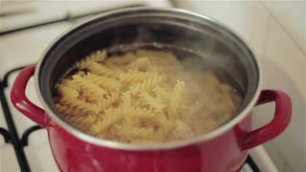
2. Boil 350g spiral pasta for 2 mins less than stated on the pack, then drain.

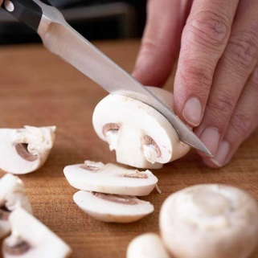
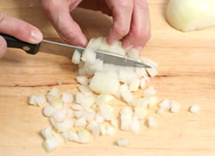
3. Chop the onions and slice the mushrooms. Cook for 5 minutes in a frying pan.

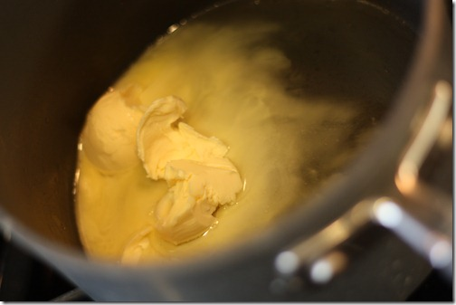
4. Melt the butter in a saucepan on a low heat

5. Stir in the flour and cook for 1 min

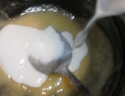
6. Gradually stir in the milk and add 1 tsp of mustard.

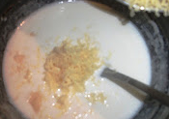

7. Take from the heat and stir in the cheese.

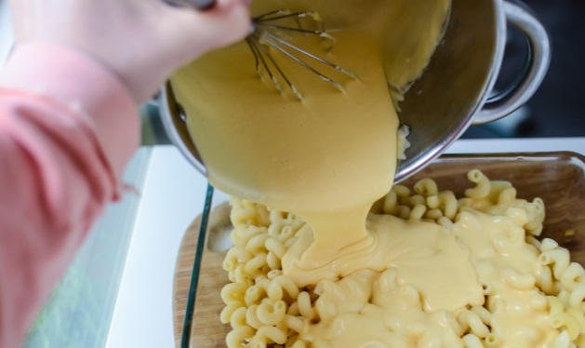
8. Put the onions, mushrooms and pasta into an oven proof dish. Then cover with the cheese sauce.

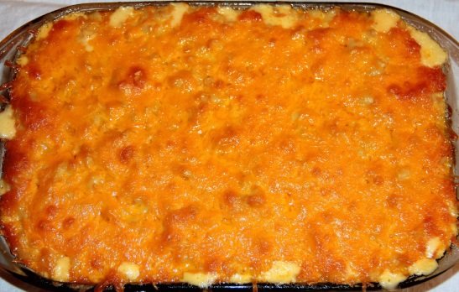

9. Bake for 20 mins until crisp and golden.

